Django Project for HttpRespone

1)Create a Virtual Environment and Activate

**venv/Scripts/activate**

is a critical step in isolating your project's dependencies and ensuring that you're using the correct Python environment

2)Install Django and Dependencies: Once the virtual environment is active, you can install Django and any other dependencies your project needs using pip:

**pip install django**

3)Create a new Django project using the following command:

**django-admin startproject http_response_project** .

The command django-admin startproject http_response_project . is used to create a new Django project in the current directory (represented by .).

4)Now, create a new Django app within your project:

**python manage.py startapp myapp**

5)INSTALLED_APPS setting, add the name of the app you want to include. For example, if your app is named myapp, add it to the list like this:

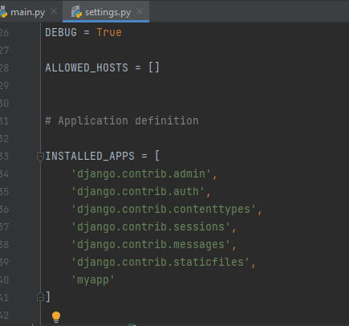

6)Inside your myapp directory, create function within views.py. This is where you'll define your functions

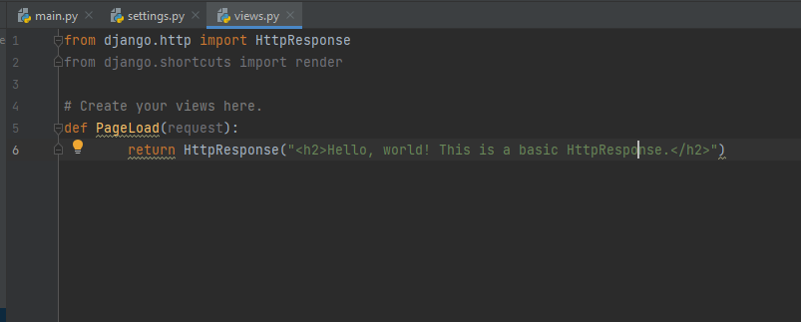.7)Now, you need to configure your URLs. In your myapp directory, create a new file named urls.py:

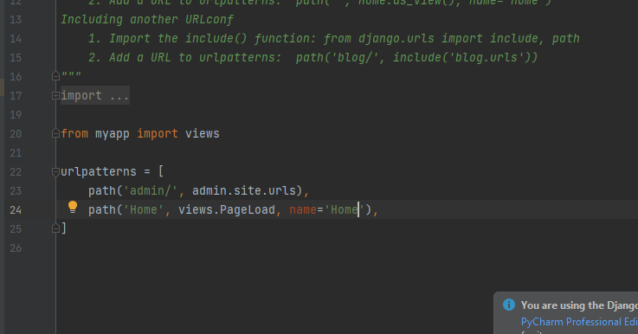

8)Now, you've set up a basic Django project with an app that contains a single view. Run the development server to see it in action:

**python manage.py runserver**

9)Visit http://127.0.0.1:8000/myapp/hello/ in your web browser, and you should see "Hello, world! This is a basic HttpResponse." displayed on the page.

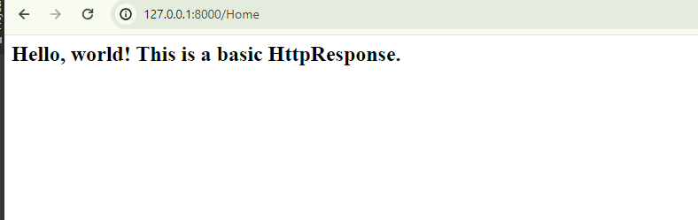

our app name here

]

python manage.py startapp myapp

django-admin startproject http_response_project

pip install django